- What is a PN junction diode?
A two-terminal semiconductor device, which allows the electric current to flow only in
one direction while blocking the electric current in the opposite or reverse direction, is
known as PN junction diode.
This device is forward biased, allowing the electric current to flow.
On the other hand, in reverse bias conditions, it blocks the electric current flow.
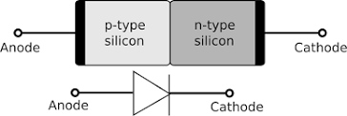

- Draw circuit symbol of Zener diode
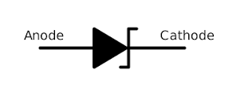
The circuit diagram symbol used to represent a Zener diode is drawn with an arrow, representing forward bias current.
At the tip of the arrow, a bent line is drawn to distinguish it from an ordinary diode.

- State the applications of Zener diode
Zener diodes are used for voltage regulation, as reference elements, surge suppressors, and in switching applications and clipper circuits ,Protects from over voltage,Used in clipping circuits,Used to shift voltage.

- What is forward biasing of a diode?
Forward bias or biasing is where the external voltage is delivered across the P-N junction diode. In a forward bias setup, the P-side of the diode is attached to the positive terminal, and N-side is fixed to the negative side of the battery. Here, the applied voltage is opposite to the junction barrier potential.

- What is reverse biasing of a diode?
The process by which, a p-n junction diode blocks the electric current in the presence of applied voltage is called reverse biased p-n junction diode.
In reverse biased p-n junction diode, the positive terminal of the battery is connected to the n-type semiconductor material and the negative terminal of the battery is connected to the p-type semiconductor material.
- Define current gain
The ratio of the output current and input current of the amplifier is called the current gain. The current gain indicates the amplifier’s capacity to deliver the maximum output current to the load with respect to a particular applied input current.
The mathematical formula of current gain is;
The current gain can also be represented by
- What is Zener breakdown?
When the diode is reverse biased, the kinetic energy of the electrons increases, and they move at a high velocity. The high-velocity electrons collide with other atoms and give rise to free electrons. These free electrons, in turn, give rise to a high value of reverse saturation current. This is known as Zener breakdown.
- Define voltage gain
Voltage gain is the ratio of output voltage to the input voltage
- What is Avalanche breakdown?
The avalanche breakdown occurs when a high reverse voltage is applied across the diode.
As we increase the applied reverse voltage, the electric field across the junction increases. This electric field exerts a force on the electrons at the junction and frees them from covalent bonds.
These free electrons start moving with high velocity across the junction and collide with the other atoms, thus creating more free electrons.
- What is a transistor? What are the different types of transistor configurations?
A three terminal device that is used to control or regulate the flow of electronic signals.
CommonBase,Common collector Common Emitter.
- What are small signal amplifiers?
Those amplifiers which handle small input a.c. signals (a few µV or a few mV) are called small-signal amplifiers.
Ex:voltage amplifiers
Amplifiers amplify the signal with little or no distortion.
- Write some applications of Zener diode.
Zener diodes are used for voltage regulation, as reference elements, surge suppressors, and in switching applications and clipper circuits ,Protects from over voltage,Used in clipping circuits,Used to shift voltage.
- Draw the forward bias V-I characteristics of PN junction diode
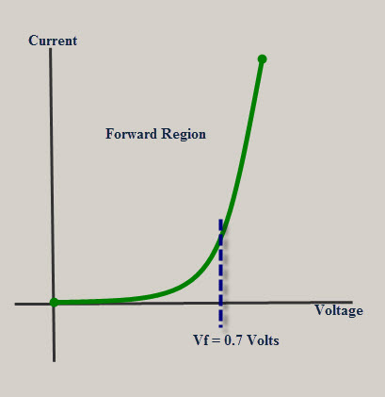
- Draw the reverse bias V-I characteristics of PN junction diode
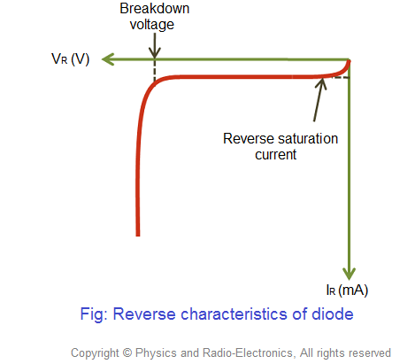
- Draw the input characteristics graph of CE configuration
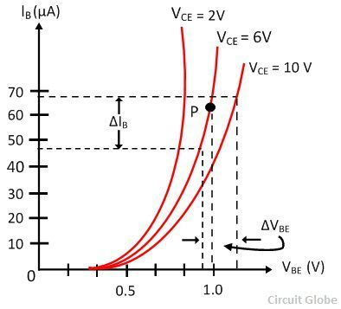
- Draw the input characteristics graph of CC configuration
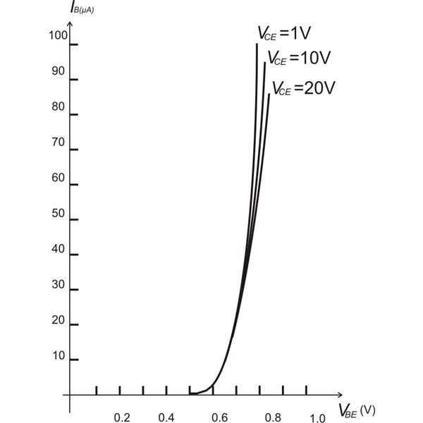
- Draw the input characteristics graph of CB configuration
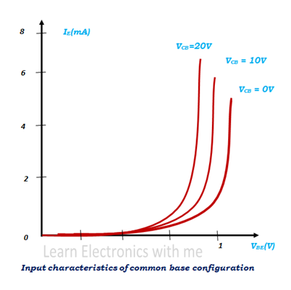
- Draw the output characteristics graph of CE configuration
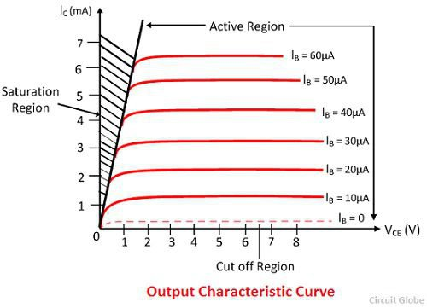
- Draw the output characteristics graph of CC configuration
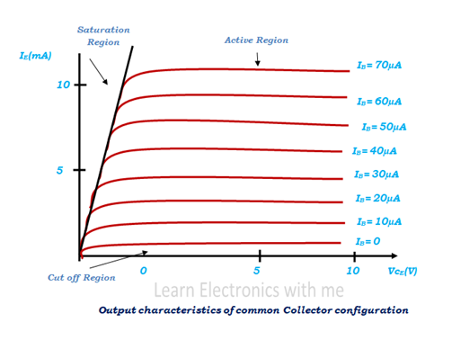
- Draw the output characteristics graph of CB configuration
